CALL FOR APPLICATIONS
Inspiration Session in the Ardennes
« Environmental stakes in storytelling »

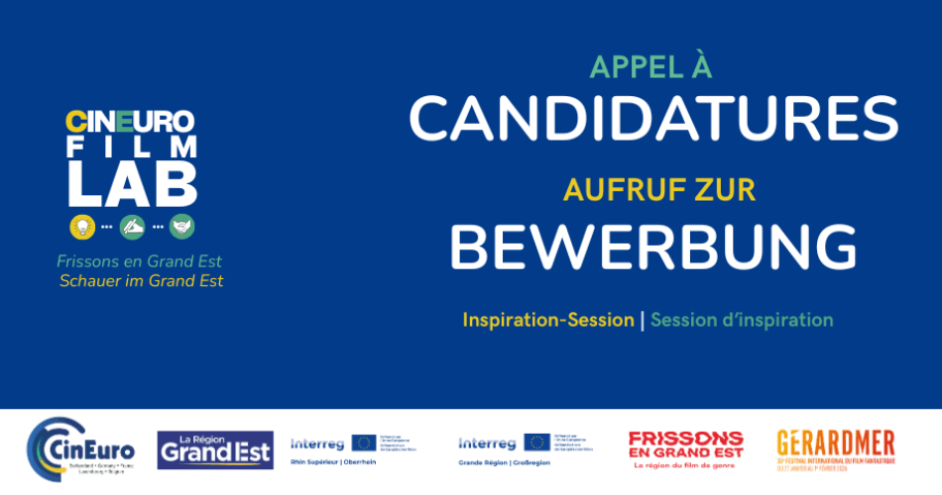
This year marks the 41st edition of the International French-speaking Namur Film Festival. On this occasion Wallimage, with the support of the Région Grand Est (FR), is launching a call for applications regarding a new Inspiration Session in the Ardennes. The goal of this program is to create a delegation of ten professionals who will all participate to these visits from the 28th to the 30th of September 2026.
This delegation, supported by the FIFF, aligns itself with a cross-border cooperation dynamic. Its objective is to help professionals from the film and audiovisual industry coming from CinEuro’s partner territories wishing to exchange and to develop both collaborations and collaborative projects all dealing with the creation of movie scenarios with one common context: climate change.
During the three days of the program, the ten participants will benefit from both a personal support as well as a tailor-made exploration program of the local ecosystem surrounding the French and Belgian Ardennes. This itinerant route will take them to the heart of the beautiful Ardennes Mountain range, from Charleville-Mézières all the way to Namur, with the guidance of specialized local partners.
Program
- Monday, September 28th: Charleville-Mézières
Beginning of the program at 12PM in Charleville-Mézières
Arrival to the city and introduction to the PLATO network
Exploration of the Voie Verte by foot
- Tuesday, September 29th: Chooz
Visit of the Chooz nuclear plant
Meeting with experts and witnesses of its integration in the Meuse valley landscape
- Wednesday September 30th : Gérardmer
Trip to Namur (41st Festival International du Film Francophone de Namur/ International French-speaking Namur Film Festival)
Visit of the Town and its citadel
Meetings and exchanges with experts in green storytelling (partnership with ASA – Association des Scénaristes de l’Audiovisuel (BE)
Festival opening party (by invitation)
End of the program

Buses from Namur to Bruxelles and Charleville-Mézières on October 1st.

Practical information and coverage of fees
This call for application is intended for professionals from the film and audiovisual industry (authors, directors and producers). It is important to manifest a strong interest in green storytelling (stories tackling topics such as climate change and/or environmental problematics). The priority will be given to participants originating from the territories of the CinEuro network*.
However, scenarists and directors from other territories are welcome to apply if they intend to develop (or already did) pieces of audiovisual media dealing with green storytelling in the CinEuro territories.
The working language will be French.
Lunch, dinner and housing fees (3 nights) will be handled by the organizer.
Travel fees for trips during the program, as well as the trip back to Charleville-Mézières in minibus will be handled by the organizer. However, the expenses for the trip to the start of the program (Charleville-Mézières) will be handled by the participants.
The precise terms and conditions will be communicated to the selected participants.
NB : The CinEuro* territories are the cooperation spaces of the “Rhin Supérieur” and the “Grande Région” : Brussels-Capital Region, Wallonia, Luxembourg, Saarland, Rhineland Palatinate, Baden-Württemberg, Grand Est, Cantons of Basel-Stadt, Basel-Landschaft and Aargau.

How to candidate
Please fill in this form to apply. Deadline: August 30 2026
Form link: https://forms.gle/s5cMtqEbKjBzSQeY7
Contact: Jean-François Tefnin - jft@wallimage.be
------------
This event is proposed within the thematic sequence of « Nature et Paysage » of CinEuro Film Lab, a project cofinanced by the INTERREG programmes Grande Région/Grossregion and Rhin Supérieur/Oberrhein.

